Source https://deluxeiceland.is/luxury-tours/northern-lights-adventure/
__________________________________________________________

Chasing the Northern Lights in Iceland
__________________________________________________________
★★★★★ 4.7/5 25 reviews

Add to wishlist ♡

__________________________________________________________

6 days | From €4,360 per person

🏕  Image | 🏕  Image | 🏕  Image | 🏕  Image | 🏕  Image | 🏕  Image

__________________________________________________________
About This Tour
Experience an unforgettable 6-day adventure through Iceland's magical landscapes. With your own private guide, you’ll explore the highlights of Southern Iceland, including geothermal wonders, volcanic landscapes, and charming Icelandic farms. Relax in the rejuvenating Blue Lagoon and chase the awe-inspiring Northern Lights. Whether you’re looking for relaxation, adventure, or family-friendly activities, this tour is perfect for all!
__________________________________________________________
What’s Waiting for You
- Duration: 6 days / 5 nights
- Group Size: Private group, ideal for families, couples, or small groups
- Accommodation: 3 nights at Hotel Rangá, 2 nights at Hotel Borg (Deluxe Room with breakfast)
- Languages Available: English, Spanish, French
- Private Guided Tour: Fully personalized experience with your own guide
- Transportation: Comfortable, private transportation throughout your trip
- Season: Available from 15 Sept to 15 April
__________________________________________________________

Check Dates & Availability

Select participants: (Age 99 and younger) - 1 +

Choose date:
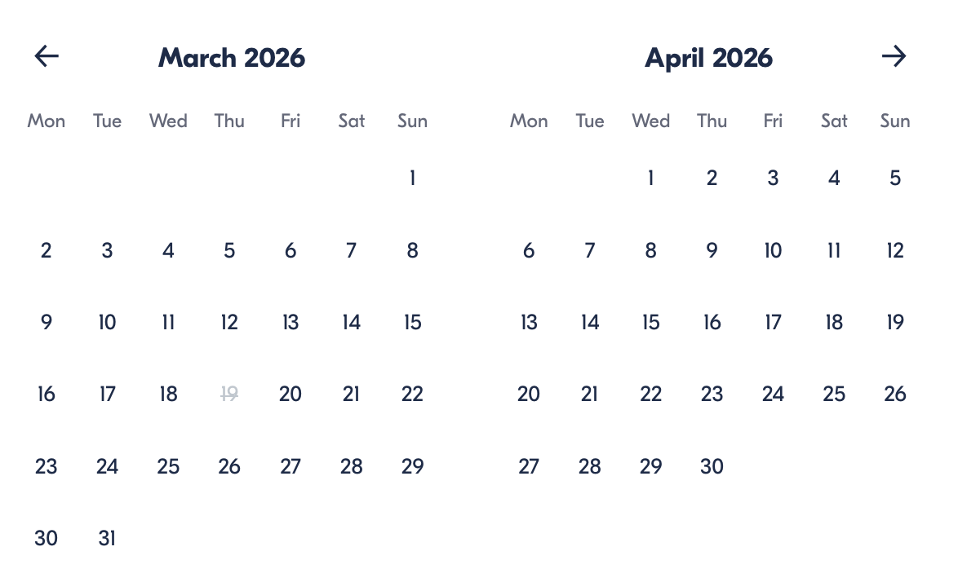

Check Availability

opens:

Participants: 2 March 16, 2026

Chasing the Northern Lights in Iceland

- Duration: 6 days
- Offered in: English
- Starts at: 10:30 AM

Cancellation:

- More than two weeks prior to arrival: 40% Credit / 60% Refunded
- Less than two weeks prior to arrival: 50% Credit / 50% Refunded
- Less than 72 hours prior to arrival: No refund and no credit

Price breakdown: 2 Participants x €4,360

Total: €8,720

The total price includes all taxes and fees.

Add to cart Book now

__________________________________________________________
Tour Features
- Blue Lagoon: Relax in Iceland’s world-famous geothermal spa with exclusive access to the Retreat Spa.
- South Coast: Explore the stunning waterfalls of Skógafoss and Seljalandsfoss.
- Geothermal Energy & Lava Center: Dive into Iceland’s volcanic history at the Lava Center.
- Farm Visits: Experience Icelandic farm life and enjoy a traditional Icelandic pancake.
- Northern Lights Viewing: Witness the magical Northern Lights from the perfect vantage point.
__________________________________________________________
Detailed Itinerary
- Day 1 – Arrival & Blue Lagoon Relaxation
Upon arrival at Keflavik Airport, your private driver will greet you and escort you to the world-famous Blue Lagoon. Enjoy exclusive access to the Retreat Spa, where you can soak in warm geothermal waters amid stunning volcanic landscapes. Feel free to spend up to five hours in the spa, with a light meal available at the on-site restaurant. Afterward, relax during a scenic 1.5-hour drive to your accommodation at Hotel Rangá in South Iceland, where you’ll settle in for the night.
Accommodation:
Hotel Rangá, South Iceland – Deluxe Room with breakfast (Included in price)
__________________________________________________________
- Day 2 – South Shore & Farm Visit
Today, immerse yourself in the beauty of Iceland’s South Coast. Begin your adventure with a visit to a local Icelandic farm, where you’ll get a glimpse of farm life, enjoy a cup of coffee, and try Icelandic pancakes. Then head to Reynisfjara, the iconic black sand beach, where you’ll see the Reynisdrangar Cliffs. Continue to Skógafoss, one of Iceland’s most majestic waterfalls, with a drop of 60 meters. You’ll even have the chance to walk right up to the falls! On your way back, stop at Seljalandsfoss, a waterfall you can walk behind for a unique perspective. Finally, head back to Hotel Rangá to relax for the night.
Accommodation:
Hotel Rangá, South Iceland – Deluxe Room with breakfast (Included in price)
__________________________________________________________
- Day 3 – Lava Center, Golden Waterfall & Hot Springs
Start your day by learning about Iceland’s volcanic history at the Lava Center, followed by a visit to the stunning Kerid Crater Lake, a 3,000-year-old volcanic crater. After exploring the crater, enjoy a delicious taste of Icelandic bread at Laugarvatn Geothermal Bakery, where the bread is baked using geothermal heat. Continue your adventure to Geysir Geothermal Area, where you'll witness the impressive Strokkur geyser erupting water 30 meters into the air. Next, visit Gullfoss, one of Iceland's most beautiful and powerful waterfalls. End your day with a relaxing dip in the Secret Lagoon, a geothermal hot spring in Flúðir. On the way back, enjoy Tomato Soup at Fridheimar Greenhouse, known for its fresh produce.
Accommodation:
Hotel Rangá, South Iceland – Deluxe Room with breakfast (Included in price)
__________________________________________________________
- Day 4 – Buggy Adventure & City Tour
Today, journey to the Reykjanes Peninsula for a thrilling 3-hour Buggy Adventure through lava fields. Feel the excitement as you drive through rugged Icelandic terrain. After the buggy ride, head to Reykjavik, Iceland's vibrant capital. Visit Hallgrimskirkja Church, where you can take in panoramic views of the city from the tower. Explore Solfar Sun Voyager, the Harpa Concert Hall, and the Old Harbour, then finish the tour with a visit to Bessastaðir, the official residence of the President of Iceland. Your private guide will ensure you see the best of Reykjavik’s attractions before taking you back to your hotel.
Accommodation:
Hotel Borg, Reykjavik – Deluxe Room with breakfast (Included in price)
__________________________________________________________
- Day 5 – Discover Reykjavik & The Northern Lights
Spend the day exploring Reykjavik at your own pace. Your hotel is conveniently located near the city’s main attractions, including shops, cafes, museums, and art galleries. In the evening, we’ll keep the Northern Lights tour open. Based on weather conditions and the aurora forecast, you’ll receive an update each day on whether the tour will operate that night. If conditions are favorable, the tour will depart at 9:00 PM to offer the opportunity to witness the Northern Lights. Please note that sightings cannot be guaranteed as the aurora is a natural phenomenon, but our expert guides will take you to the best possible locations for viewing.
Accommodation:
Hotel Borg, Reykjavik – Deluxe Room with breakfast (Included in price)
__________________________________________________________
- Day 6 – Departure
On your final day, your private driver will pick you up from Hotel Borg and take you to Keflavik Airport in time for your departure. Please arrive 2 hours before your flight’s departure for a smooth check-in. Reflect on your unforgettable adventure in Iceland and cherish the memories made.
__________________________________________________________
Included in Price
- Private guide for the entire tour
- Private transfers between all locations
- Premium access to the Blue Lagoon Retreat Spa
- Geothermal Bakery Bread Tour
- Tomato Soup at Fridheimar
- Private Buggy Adventure Tour
- Entrance to the Lava Center
- Farm Visit with guided tour
- Accommodation: 3 nights at Hotel Rangá, 2 nights at Hotel Borg (Deluxe Room with breakfast)
- All taxes and fees – no hidden charges
__________________________________________________________
Not Included
- Meals (Lunches and dinners are not included)
- International flights
- Optional activities (snowmobiling, ATV tours, etc.)
__________________________________________________________
Who Should Avoid This Tour
- Pregnant Travelers: Due to the physical nature of activities such as snowmobiling and hiking, pregnant travelers should consult with their doctor.
- Travelers with Mobility Issues: Some terrain, especially on the Golden Circle and the South Coast, may not be wheelchair-accessible.
- Heart Conditions: The cold temperatures and physical activities may not be suitable for travelers with heart conditions.
- Young Children: Some longer excursions and the cold may be challenging for children under 3.
__________________________________________________________
Important Trip Info
- Duration: 6 days with some longer sightseeing days. Be prepared for active excursions, including hiking, buggy rides, and outdoor activities.
- Weather: Iceland’s weather is unpredictable. Pack warm, waterproof layers, gloves, and hats. Expect cold and windy conditions even during summer.
- Meals: Meals are not included, but we recommend trying local Icelandic cuisine. There are many excellent restaurants near your accommodations.
- Northern Lights: While sightings are not guaranteed, your guide will take you to the best viewing spots.
- Fitness Level: The tour involves some physical activities, like hiking and snowmobiling. A basic level of fitness is required.
- Punctuality: Be on time for all departures, especially the Northern Lights hunt.
- Emergency Contacts: In case of any issues, your guide and emergency support contact details will be provided.
__________________________________________________________

Cancellation Policy
For 5 or Fewer Participants:
- More than 2 weeks before arrival: 40% Credit / 60% Refund
- Less than 2 weeks before arrival: 50% Credit / 50% Refund
- Less than 72 hours before arrival: No refund or credit
For 6 or More Participants:
- More than 4 weeks before arrival: 40% Credit / 60% Refund
- Less than 4 weeks before arrival: 80% Credit / 20% Refund
- Less than 2 weeks before arrival: No refund or credit
Changes in the number of participants may increase the price per person. We recommend comprehensive travel insurance.
Weather-Related Cancellations:
If activities are canceled due to weather, they will be fully refunded. Itineraries may change based on conditions, with safety as the top priority.
Refund Processing:
Refunds are processed within 15 days after the tour ends.
__________________________________________________________
What Our Clients Are Saying

Overall rating  4.7/5  ★★★★★  Based on 25 reviews | Review summary  Guide 4.5/5  Transportation 4.6/5  Service 4.7/5  Organisation 4.5/5

Filter  - All traveller types  - Couples  - Group of friends  - Families  By star rating  - All star ratings  - 5 stars  - 4 stars  - 3 stars  - 2 stars  - 1 star | Search reviews (e.g., guide)  Sort by:  - Top picks  - Latest reviews  - Best ratings  - Lowest ratings
__________________________________________________________
★★★★★
John P – United States of America
A truly unforgettable experience! The Blue Lagoon, the Northern Lights, and all the breathtaking sites along the way made this tour unforgettable.

★★★★★
Maria L – United Kingdom
An incredible journey! Our private guide was amazing, and we loved every moment. A perfect mix of relaxation and adventure.

★★★★☆
Sophia D – France
Une expérience fantastique! J'aurais aimé passer un peu plus de temps à Reykjavik, mais dans l'ensemble, c'était un voyage incroyable. Les enfants se sont éclatés!

See more reviews
__________________________________________________________

Meta tags

Page - Chasing the Northern Lights in Iceland

Title: Chasing the Northern Lights in Iceland | Travellio Global

Description: Experience an unforgettable 6-day journey through Iceland’s winter landscapes. Chase the mesmerizing Northern Lights while discovering Iceland’s most iconic sights, including waterfalls, geysers, and geothermal spas.

H1 - Chasing the Northern Lights in Iceland
__________________________________________________________

